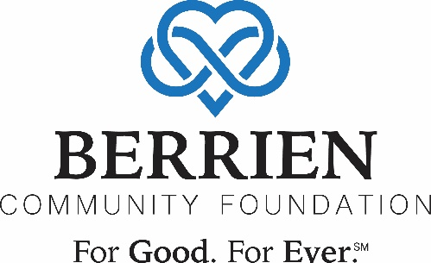

Vaccine Promotion Grant Application

Do you have an idea for a project that would address vaccine hesitancy?
The Berrien Community Foundation received a grant from Michigan State University to fund small nonprofit organizations interested in getting accurate information to the Black and Latinx communities in Berrien County about adult vaccination. The goal is for people to be equipped with good data and answer questions to make informed decisions about vaccinations.
Now, the focus is on the COVID-19 vaccine, but this grant is to address COVID-19 vaccine hesitancy along with other important vaccines such as the flu vaccine, shingles vaccine and pneumonia vaccine.
The key is for small organizations – nonprofits, churches, etc. – that are strongly connected in the community to be the trusted source of information. Below is a simple grant application to apply for funding for your organization’s idea.
If you want to get involved but aren’t sure how to help, please contact Susan Matheny at 269-983-3304. We would love to have a conversation with you and see how we can partner
Eligible organizations can be 501c3 nonprofits, religious organizations doing community work, schools, municipalities or other organizations partnering with one of the previously listed eligible organizations. To review eligibility requirements, please visit www.berriencommunity.org/vaccinegranteligibility.
All applicants have the option for submitting an application via ONE of the following paths:
- Online Application Form at www.berriencommunity.org/vaccinegrant
- Word Document submitted via email to Susanmatheny@berriencommunity.org.
- Mail or deliver in person to Berrien Community Foundation, 2900 S. State Street, Ste. 2E, St. Joseph, MI, 49085
Applications will be reviewed weekly starting March 7. Grants will be awarded shortly thereafter.

ORGANIZATION INFORMATION
Name of Organization: [Type here]
Organization Address: [Type here]
FEIN #/Tax ID#: [Type here]
Contact Person: [Type here]
Phone: [Type here]
Email: [Type here]
Is this a partnership? If so, please list all the groups who are involved. Note: Eligible organizations can be 501c3 nonprofits, religious organizations doing community work, schools, municipalities or other organizations partnering with one of the previously listed eligible organizations.
[Type here]
Tell us about your organization. Briefly tell us about your organization/partnership. Tell us about the people/places you serve, what types of activities you do, the goals of your work.
[Type here]

ABOUT THE PROJECT
1. Project Summary
What activity/activities are you proposing to do to help encourage vaccinations in the adult population of Black and Latinx community members in Berrien County?
[Type here]

2. Project Timeline
When will this project be done? If it is multiple dates, please list them.
[Type here]

3. Approximately how many people will you serve with this project?
[Type here]

4. Do you need anything from Berrien Community Foundation? For example, do you need help with marketing?
[Type here]

5. Amount Requested: $[Type here]

6. Please provide a budget.
Budget should include anticipated personnel costs, supplies and materials, and any other anticipated costs necessary to meet program goals. You may write out a budget below or you may attach your budget as a separate document.
[Type here]

